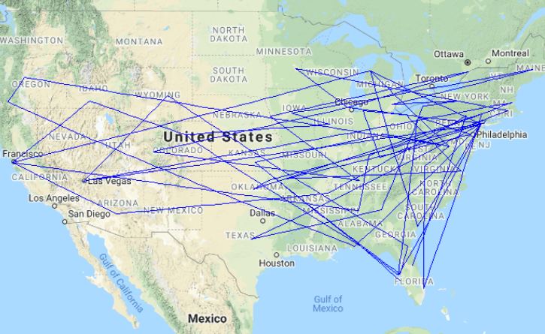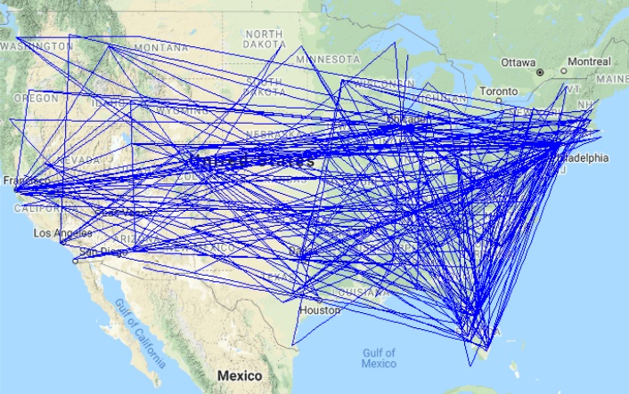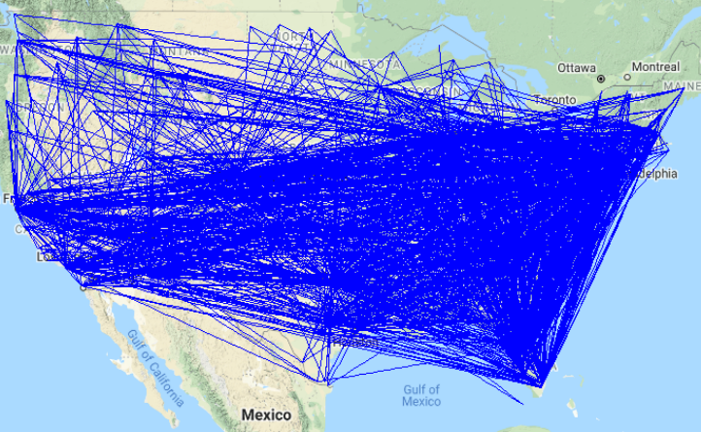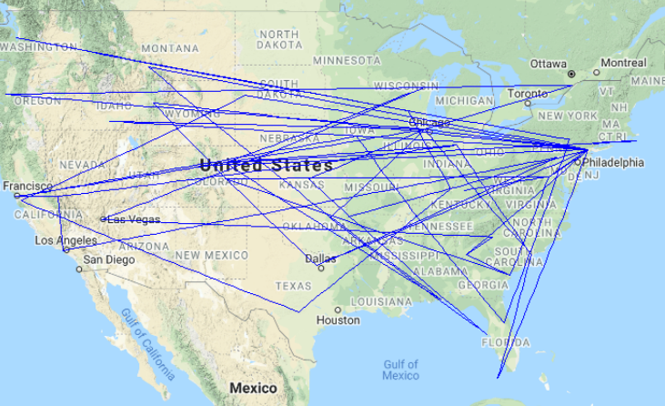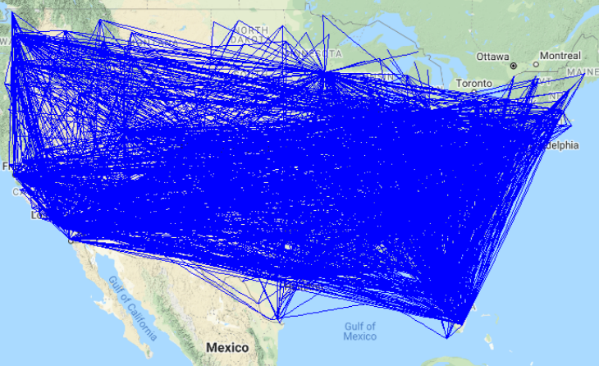

Routes with Average 45-60 Minutes of Delay

Routes with Average 30-45 Minutes of Delay

Routes with Average 15-30 Minutes of Delay

Routes with Average 60+ Minutes of Delay

Routes with Average 0-15 Minutes of Delay